Objectives:

* Connect a database system to ASP
* Using the select & insert commands
* Using CSS

**There are 1 print screen worth 100%**

1. Start a new Visual Basic ASP project
2. To create a new page, click on the project menu >> Add New Item >> Web Form >> and rename the web form to **Login.aspx**

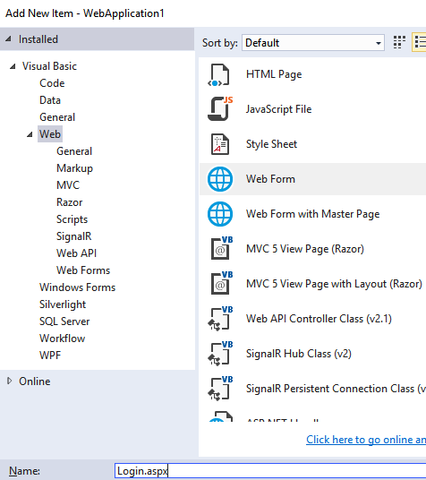

1. Type *Login Page* between the Title tag and create a <h1> and <h2> headers as shown below

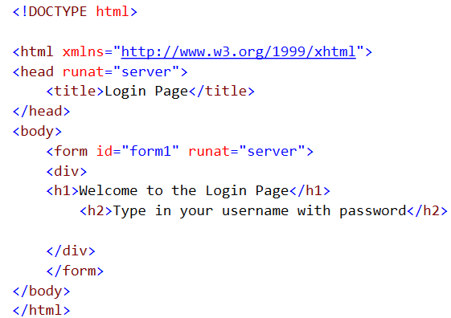

1. Go to the design tab and insert a new table by clicking on the Table menu >> Insert Table then click OK

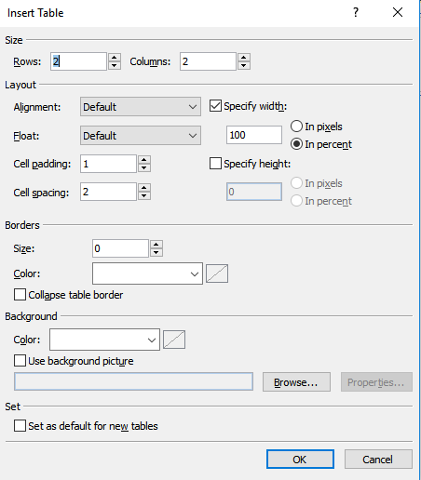

1. Include the following tools and change the properties as shown below. Note: There are 2 **Required Field Validators** for the text boxes

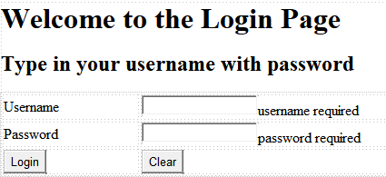

1. Open a Access Database >> click on blank Database>> and name it **ASP Database** click on the browse folder and place it on your desktop

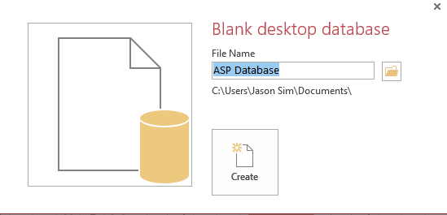

1. Right click on the Table1 and rename it to Login

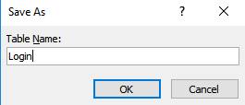

1. Create the following 2 fields

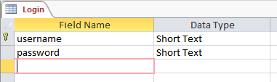

Note: the yellow key is called the primary key this will ensure that the username cannot be duplicated

1. To save and insert data, double click on the table and insert the following

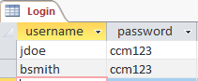

1. Completely exit the database. We will not connect to the database from the ASP app
2. To retrieve the provider open the Data components under the toolbox and click and drag the (SQL Data Source)

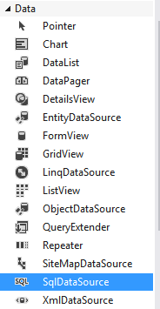

1. Click on the Configure Data Source link



1. Click on the New Connection button

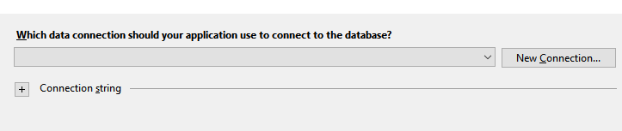

1. Point to the Microsoft Access Database File

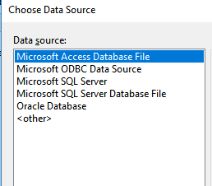

1. Browse to the database and click on the Test Connection button, you will get the following below

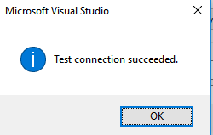

1. Expand the Data Connection String and copy it.

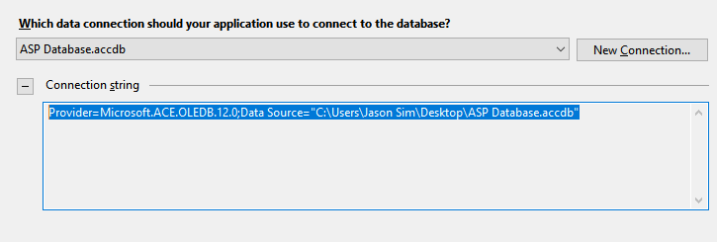

1. Proceed with all DEFAULTS
2. Paste what you copied in the OleDBConnection class



Note: ensure that there is only 1 starting double quotation and 1 ending double quotation

1. Create a 2nd page named **Customers.aspx**
2. Under the login button complete the rest of the code

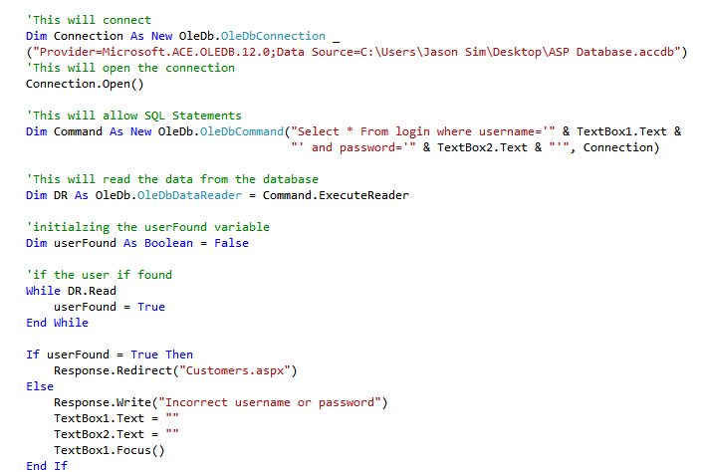

1. Test the page and after the successful test design the following on the Customers page

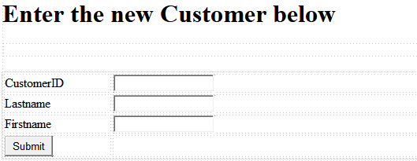

1. Create a 2nd table called Customers

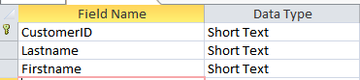

1. Double click on the Submit button and type in the following code

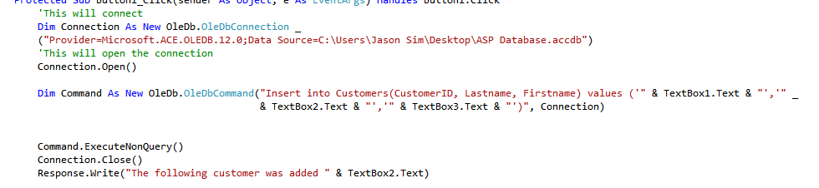

1. Execute and add a new customer

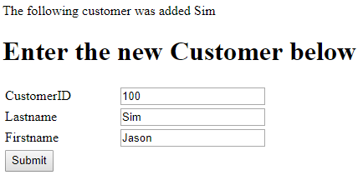

1. Check the database to see if it written the new data

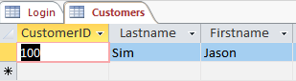

1. Now, we will added some CSS (Cascading Style sheet) to give some style to our button controls
2. Add a new Style Sheet

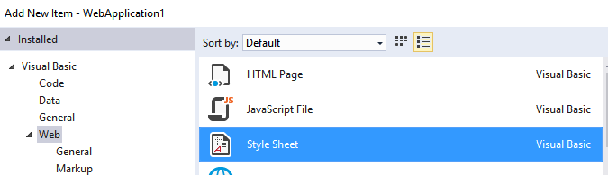

1. Type in the following:

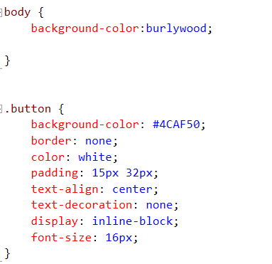

1. Now, we will link it to the Login page

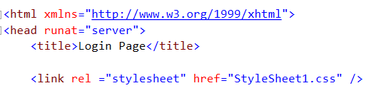

1. Call it from the button controls

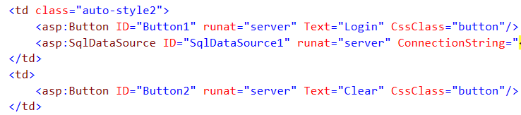

1. The Page should look like this

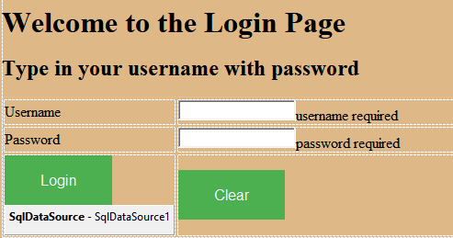

**Print screen the Welcome Login Page below here**

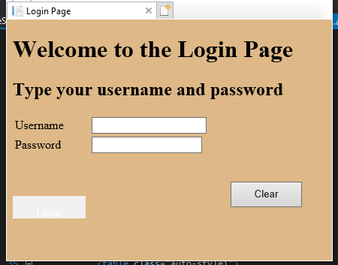

**Submit this document to Module 10 Class Exercise**